**BANK LOAN REPORT QUERY DOCUMENT**

1. **BANK LOAN REPORT | SUMMARY**

KPI’s:

**1.Total Loan Applications**

SELECT COUNT(ID) AS Total_Loan_Applications FROM bank_loan_data



**MTD Loan Applications**



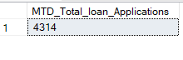

**PMTD Loan Applications**







2. **Total Funded Amount**





**MTD Total Funded Amount**



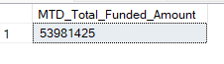

**PMTD Total Funded Amount**





3. **Total Amount Received**





**MTD Total Amount Received**





**PMTD Total Amount Received**





**4. Average Interest Rate**





**MTD Average Interest**





**PMTD Average Interest**





**5.Avg dti ,MTD_Avg_dti , PMTD_dti**

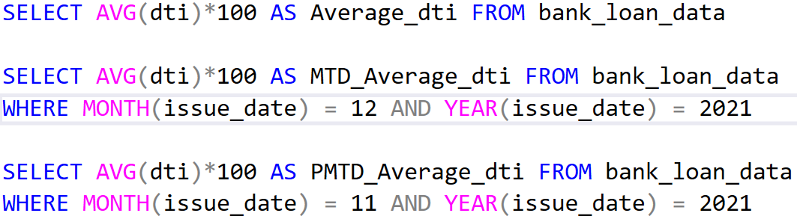

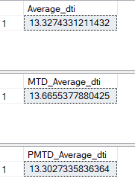

**GOOD LOAN ISSUED**

Good Loan Percentage

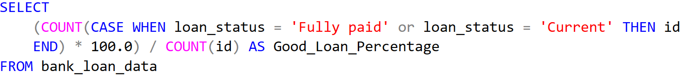

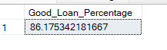

Good Loan Applications





Good Loan Funded Amount





Good Loan Amount Received





**BAD LOAN ISSUED**

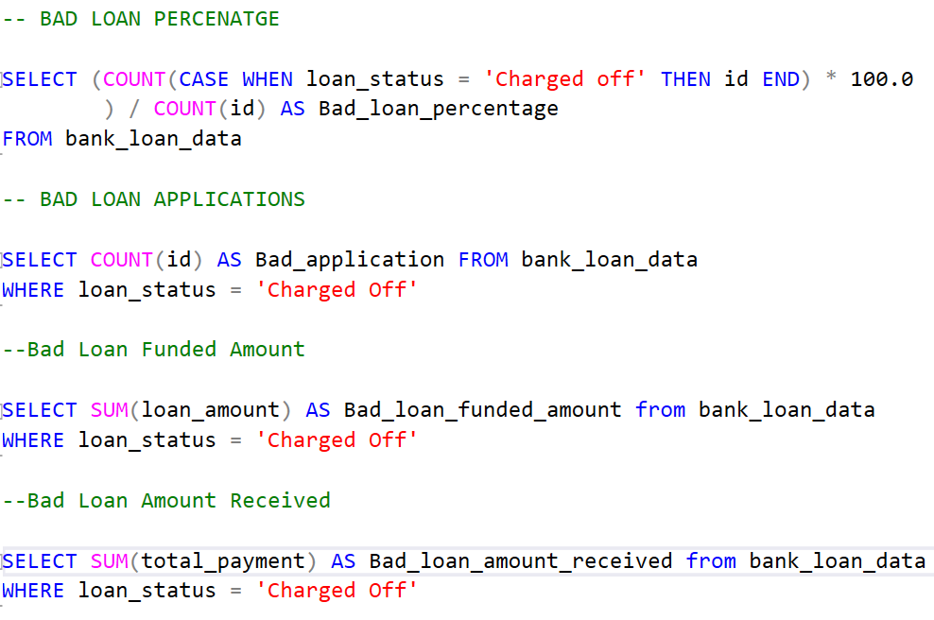

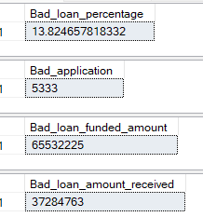

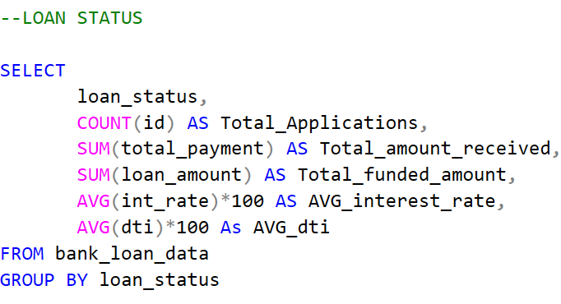

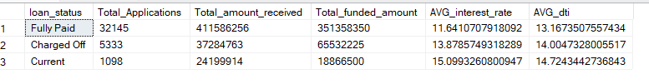

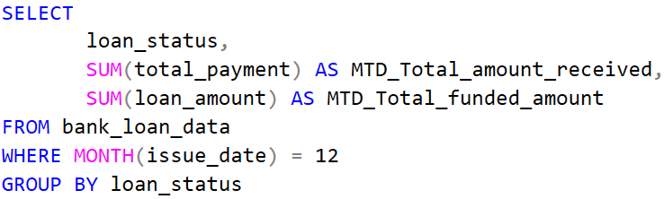

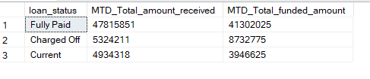

**BANK LOAN REPORT | OVERVIEW**

**MONTH**



